**MCB 525, Fall 2016**

**1.4: Agarose gel electrophoresis**

**Objective:** To confirm the effectiveness of the DNA digest, we will visualize the digested and undigested DNA from each sample via agarose gel electrophoresis.

**Protocol:**

1. Because you will only be using 5 lanes, you can run this gel with another lab group.

1. Prepare a 1% agarose gel by melting 0.5 g of agarose in 50 mL 1x TAE buffer in an Erlenmeyer flask.
2. After the melted agarose has cooled, add 2.5 μL Midori Green directly to the flask and mix by swirling the flask before pouring the gel.
3. For each sample, combine 2 μL digested DNA with the appropriate amount of 6x loading dye and H2O to give 6 μL total.
4. Repeat step d with a comparable amount of undigested DNA (reserved from yesterday).
5. Prepare the 1kb+ ladder (2.5 μL ladder with appropriate volume of 6x loading dye and water).
6. Load samples on agarose gel. Run gel for ~35 minutes at 100 volts.
7. Visualize gel. High quality genomic DNA should appear as a single high-molecular weight DNA band >10kb, while digested samples should have a slight downward shift with a trailing smear (may be difficult to distinguish if original DNA is degraded).

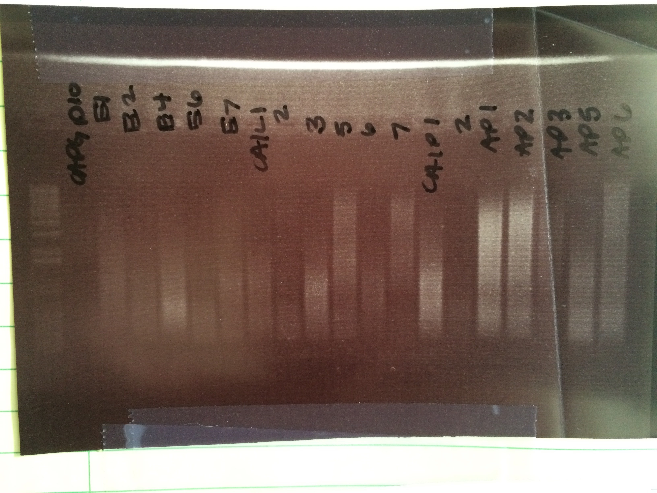

1 kb+ ladder

1 2 3 4 5 6 7 8 9 10 11 12

10kb 🡪

4 kb 🡪

2 kb 🡪

1 kb 🡪

*~~~*

1. *The above image shows DNA in various stages of degradation. Which of the above samples would be the best candidates for genomic library preparation?*
2. *Is DNA positively or negatively charged? What would happen if you mixed up the positive and negative leads when you ran the gel?*